LAB Logbook

Lab 1

Lab 2

Accuracy: 0.958

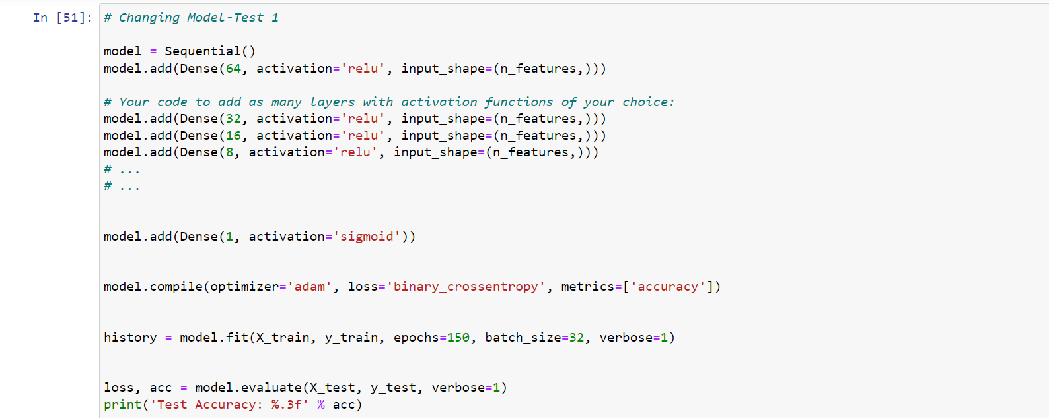

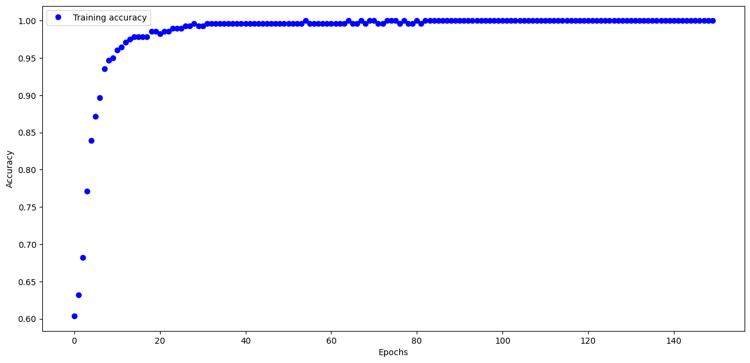

O1: 0.8226

O2: 0.8226

Lab 3

Lab 4

Lab 5

Lab 6

Lab 7

Lab 8

Lab 9

Lab 10

Lab 11

Lab 12